# SoP Next Steps

Recently a friend referred me to a paper from Harvard’s Joint Center on Housing Studies (JCHS) about “defining suburbia.” While looking at the Center’s research, I found this interesting brief: [Mapping Over Two Decades of Neighborhood Change in the Boston Metropolitan Area](https://www.jchs.harvard.edu/research-areas/research-briefs/mapping-over-two-decades-neighborhood-change-boston-metropolitan-area). It’s a great example to follow.

Like the JCHS brief, I hope to visualize a few key variables of interest for the DVRPC Region from 1990 to 2010. These variables include measures of poverty, income, unemployment, population, housing, race, and ethnicity. Unlike this brief, which features a sophisticated web map, I expect to produce either a) static maps of neighborhood change from 1990 to 2010 or b) a basic story map with the exact same information. I also intend to add three components I didn’t see in the JCHS brief, including additional metrics that quantify the spatial concentration or dispersion of our variables over time, regression analysis to identify the variables that most closely track an increase in low-income residents, and a handful of municipal-level case studies driven by the findings of the regression.

This document gives a general overview of the four research components that I hope will make a useful product for DVRPC and our member governments. The four components weave in subjects of interest brought up in internal meetings (public housing locations, change of housing prices over time) but do not include subjects for which we don’t have adequate data (public health). **The hard work for components 1 through 3 is already done.**

## 1. Descriptive Maps

Map the percentage difference from 1990-2017 for the following variables at the census tract level. These maps will give a general sense of the spatial distribution of change in the region.

|  |  |
| --- | --- |
| **Variables** | **Justification** |
| Pct. Low-Income Residents (Incomes below 199% FPL)  Pct. Extremely Low-Income Residents (Incomes below 100% FPL)  Median Household Income  Unemployment Rate | Since the purpose is to identify changes in low-income populations in the region, it follows that we will look at variables about income and poverty first. |
| Population | Some census tracts have had large increases or decreases in population relative to the region. Major population changes can tell us something about the perceived desirability of neighborhoods, the available tax base, and the resulting opportunities there. |
| No. Housing Units  Tenure (Pct. Own)  Median Home Value  Pct. Vacant Housing Units | The number of housing units can give us a sense of neighborhoods where properties are being demolished and where growth in the housing stock isn’t tracking population growth. I’ve seen significant changes in ownership patterns, home values, and vacant housing units in the region from 2010 to 2017. |
| Pct. Racial Minority  Pct. Ethnic Minority | The percentage of ethnic minority residents shows up in regressions as the strongest correlate in measuring changes in low-income residents. |

## 2. Summary Measures

Compute the following metrics for the region, the City of Philadelphia, the NJ suburbs, and the PA suburbs for the years 1990, 2000, 2010, and 2017. While the maps help provide spatial context, the summary measures will give a more detailed temporal view of change in the region.

|  |  |
| --- | --- |
| **Variables** | **Justification (and/or Caveat)** |
| Population  No. Housing Units  Tenure (Pct. Own)  Median Home Value  Pct. Vacant Housing Units  Pct. Racial Minority  Pct. Ethnic Minority  Pct. Low-Income Residents  Pct. Extremely Low-Income Residents | Since these variables were used in maps, it makes sense to summarize them as well. |
| Income Inequality | The income inequality metric (Theil index) can only be computed for 2010 and 2017 and is likely only available at the county level unless I can reasonably aggregate geographies. But its benefit is comparison over time: we can quantify an increase or decrease in income inequality. |
| Concentration of racial minority neighborhoods  Concentration of ethnic minority neighborhoods  Concentration of low-income residents (incomes below 199% FPL)  Concentration of extremely low-income residents (incomes below 100% FPL) | These metrics are called dissimilarity indices, and they allow us to quantify spatial concentration and dispersion over time. |
| Distance to City Hall by Pct. Low-Income Residents | Visualize the spatial dispersion of low-income residents over time (see below—census tracts with large concentrations of low-income residents *are* getting farther out of Philadelphia). |

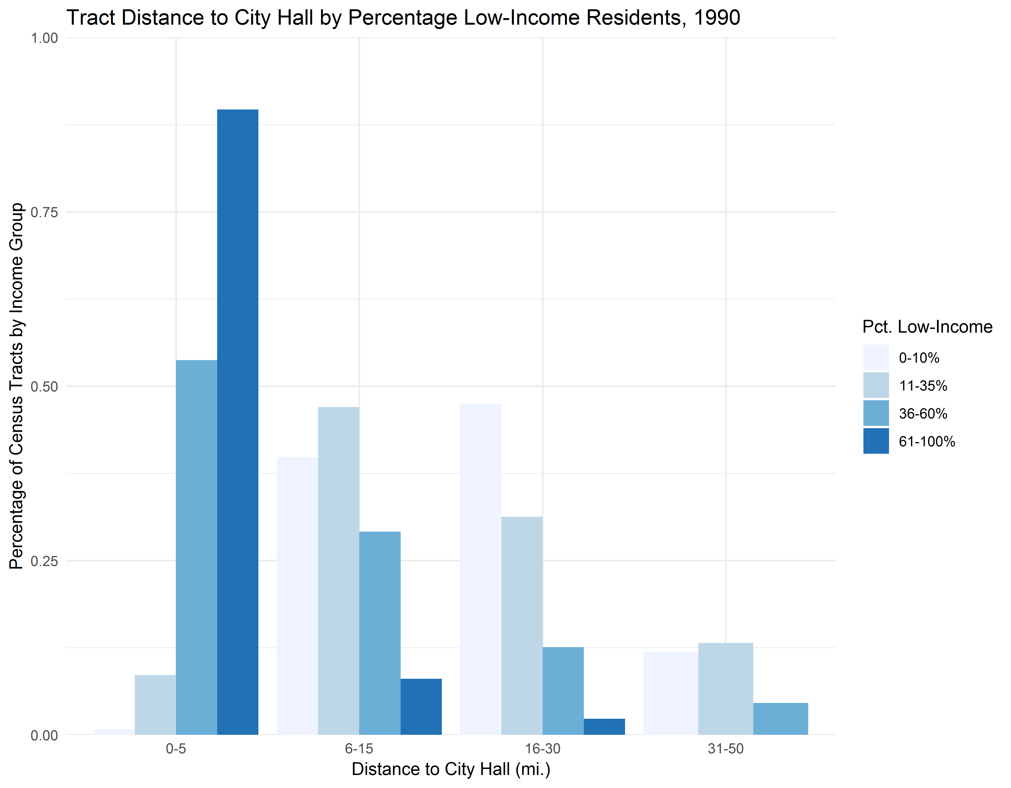

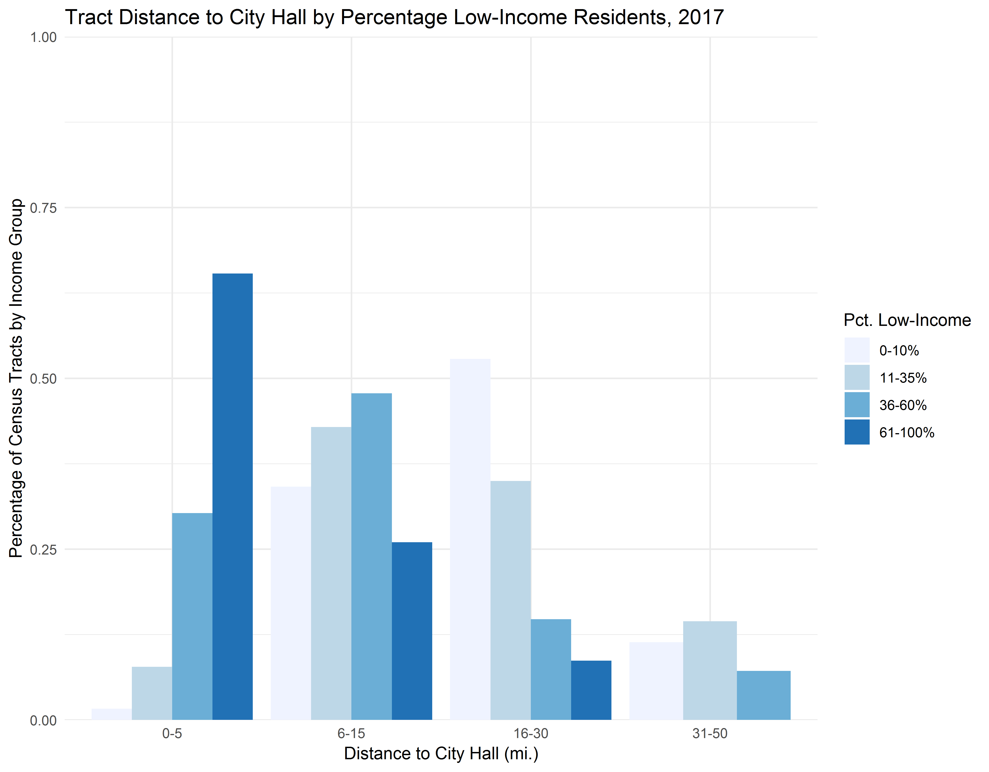

## 3. Statistical Testing for Neighborhood Change 2010-2017

Determine what factors correlate most strongly with a) changes in the percentage of low-income residents from 2010 to 2017 and b) the percentage of low-income residents in 2017. Once the factors are identified, we can test where statistically significant change has occurred in the last decade or so—and *places with statistically significant change in several variables are good candidates for case studies*. I’ve run some of these models already, and below is a list of variables that were strongly correlated with an increase in low-income residents. Note that these results are subject to change.

* Change in Tenure (Pct. Own)
* Change in Pct. Vacant Housing Units
* Change in Pct. Racial Minority
* Change in Pct. Ethnic Minority
* Change in Unemployment Rate
* Change in Mean Hours Worked per Week
* No. Housing Choice Voucher (HCV) Holders
* No. Low-Income Housing Tax Credit (LIHTC) Properties
* No. Jobs Accessible within a 30-Minute Transit Commute

## 4. Case Studies of Neighborhood Change

Once the areas with the most change in the areas above are identified, then we can zoom in to the MCD level and conduct a handful of case studies. Because I don’t have a background in qualitative research and am not very familiar with the region, this is when I’ll benefit from conversations with other people in the office. I do, however, suspect that I’ll be comparing the change in the MCD versus its surrounding county using some of the following metrics:

* Age composition
* Race and ethnicity
* Foreign-born
* Household type
* Median income
* Tenure
* Population density
* Commute mode share
* Housing type
* Housing age